How to Fill out the SSEP Financial Report
Step 1: Fill out the name of the Program, the BWF Grant ID, and the name of the Institution/Organization (NOTE: If you do not know your Grant ID number, please contact Samantha Moore at smoore@bwfund.org)

Step 2: Enter your Beginning Balance and the Amount Received for this year. The Beginning Balance should be the same number as the remaining balance from the previous year. If this is your first year of the grant, the Beginning Balance would be zero. The Amount Received is the total amount of funds paid within the fiscal period. For SSEP grants, this is usually $60,000 per year, but may vary depending on the request made for your grant. (NOTE: If you do not know your Remaining Balance from the previous year or the Amount Paid, please contact Samantha Moore at smoore@bwfund.org)

Step 3: Enter the Cumulative total of Funds Received. This will be equal to all funds received to date for the grant. For a first year grant with one payment, the Fiscal Year and Cumulative Total will be equal.

Step 4: Enter in the leftmost column the total Personnel, Participant Support, Institutional Supplies/Materials/Equipment, Evaluation, and Other Costs from previous years. This should be total costs from all previous years before the current fiscal year period. For a first year grant, this total would be zero. The form should automatically add all of these totals together for a cumulative total for all previous years. Alternatively, you can just enter the total of all previous years into the evaluation section instead of filling out each subcategory.

You can enter the total of all previous costs here instead of filling out the other subcategories.
Step 5: Enter in the middle column all expenses for the current fiscal year into each category (Personnel, Participant Support, Institutional Supplies/Materials/Equipment, Evaluation, and Other Costs). The form should automatically add all costs together for the Total Direct Costs for the Current Fiscal Year.
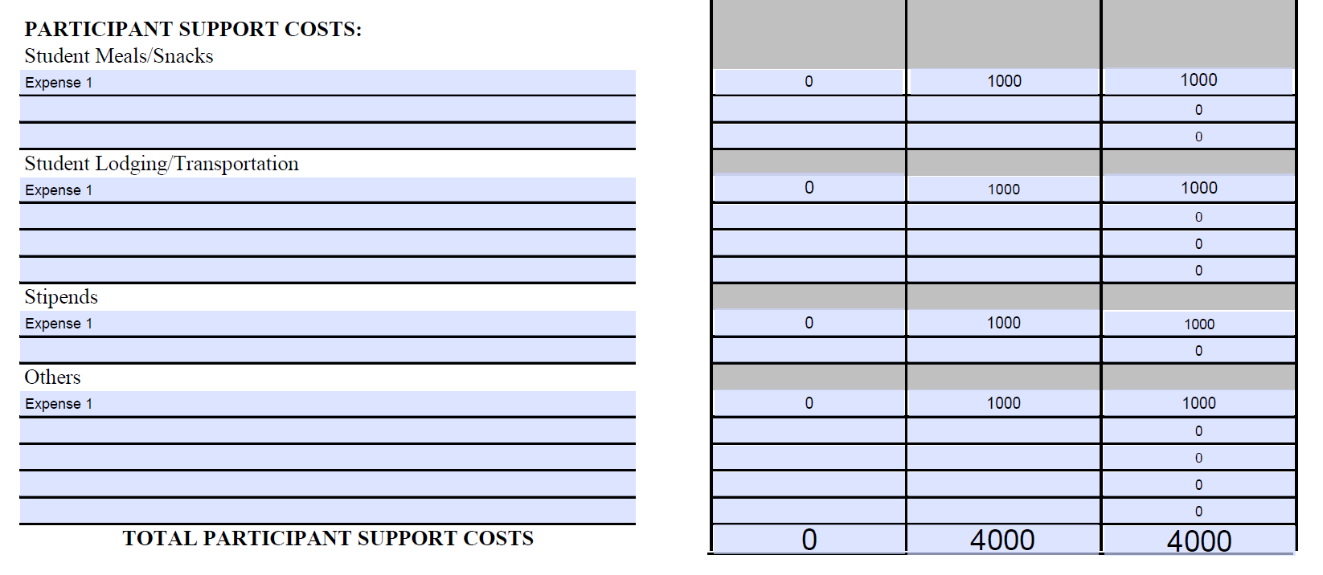
Step 6: The form will automatically add together the cumulative totals in the right column (all previous years plus the current fiscal year totals). Double check that the total direct costs of the grant matches your records. The balance is also automatically calculated. The fiscal year balance and cumulative balance should be the same amount.

Step 7: Fill out other funding sources, the name of the person filling out the form, and the date the form was completed. Be sure to double check totals in the form, especially the total costs and balance amounts. If you have any questions or problems with the form, please contact Samantha Moore at smoore@bwfund.org. Thank you for filling out your SSEP Financial report!

